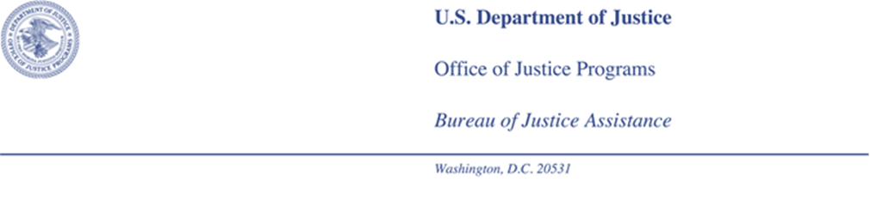

The Public Safety Officers' Benefits Act of 1976, Public Law 94-430 (PSOB), authorizes the Bureau of Justice Assistance (BJA) to prescribe the maximum fee that a representative may charge a claimant for services rendered in connection with any claim before the Bureau. Contracts for a stipulated fee and contingent fee arrangements are especially prohibited by the PSOB Regulations, 28 C.F.R. 32.7. In order to receive a fee for your services, you must complete the enclosed petition and email to my attention at hope.d.janke@usdoj.gov.

Please note that we are requesting a detailed itemization of services rendered in connection with the PSOB claim only. Fee petitions should explain how each charge or expense relates to the PSOB claim. Failure to provide such specifics will necessitate our returning your petition for such explanations, thus delaying our approval of your fee.

You must also send a copy of the completed petition to the claimant you represented, and advise the claimant of his or her opportunity to send comment on the petition within 20 days. We will not make a fee determination until 30 days after the date the petition was sent to the claimant.

We will make the determination on the basis of the criteria set forth in Section 32.7 of the PSOB Regulations. In determining the fee, BJA will consider and add the amount of reasonable and unreimbursed expenses incurred in establishing the claimant's case.

Upon making a determination, BJA will notify both you and the claimant of the amount of fee authorized, the basis for the determination, and the fact that the U.S. Department of Justice assumes no responsibility for payment. You should also be aware that the execution or attachment of any benefit paid under the Act is prohibited.

When assistance is provided pro-bono, BJA must be notified in writing that you are not charging a fee for services in connection with this claim. A copy of this notification must be provided to your client.

If further information or assistance is needed, please do not hesitate to call me directly at 202-307-2858 or toll-free at 1-888-744-6513.

Sincerely,

Hope D. Janke
Director
Public Safety Officers’ Benefits Office
Enclosure

